DATE: 11/11/2008
TITLE An experiment to investigate the Newton’s law of cooling for a liquid.
AIM To verify Newton’s law of cooling for water.
APPARATUS
Copper calorimeter with outer jacket, copper stirrer, thermometer (0°C - 100°C), beaker, ice, analytical balance (±0.01g), electric heater

DIAGRAM
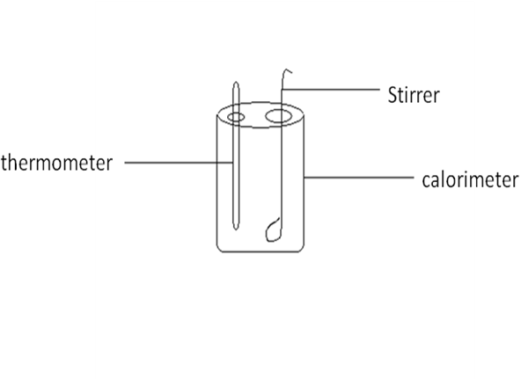
THEORY
METHOD
A calorimeter is placed on a wooden board (bad conductor) and placed near an open window. Room temperature is measured using a thermometer and recorded as θ₁°C. Water is heated in a beaker to 90°C, using an electric heater. The calorimeter is filled with the heated water to within a centimeter from the top and the lid is put on top. The thermometer and the stirrer are put in place. Keeping the cooling water well stirred, the temperatures at one minute intervals were taken till it drop to 35°C. The room temperature was recorded again at the end of the experiment with a thermometer and was recorded as θ₂°C. The results were recorded in a tabular form. The mean room temperature was obtained by finding the average of θ₁°C and θ₂°C.

TABLE OF RESULTS
Least count of thermometer = 0.1℃
Least count of stop watch =0.015s
Initial temperature of water = 90ºC
Temperature of surrounding = 31ºC
Temperature of surrounding after the experiment = 30ºC

Time/min | Temperature |  | Time/min | Temperature
0 | 90 |  | 18 | 46
1 | 84 |  | 19 | 45
2 | 82 |  | 20 | 44
3 | 78 |  | 21 | 43
4 | 75 |  | 22 | 42
5 | 73 |  | 23 | 41
6 | 69 |  | 24 | 40
7 | 67 |  | 25 | 39
8 | 64 |  | 26 | 39
9 | 62 |  | 27 | 38
10 | 60 |  | 28 | 37
11 | 58 |  | 29 | 37
12 | 56 |  | 30 | 36
13 | 54 |  | 31 | 36
14 | 53 |  | 32 | 36
15 | 51 |  | 33 | 35
16 | 49
17 | 48

GRAPH
CALCULATION
DISCUSSION
SOURCES OF ERROR
PRECAUTION
CONCLUSION
From the experiment,
REFERENCES
RAYMOND A. SERWAY, JERRY S. FAUGHN (COLLEGE PHYSICS), 6TH EDITION 2003. HARCOURT COLLEGE PUBLISHER, PAGE 312-315.
YOUNG FREEDMAN, (UNIVERSITY PHYSICS) 9TH SDITION, WESLEY PUBLISHING COMPANY, PAGE 466-469.
NELKON MICHAEL, PARKER PHILIP, (ADVANCED LEVEL PHYSICS) 7TH EDITION, PAGE 158.

